AESA NEMUS RADAR
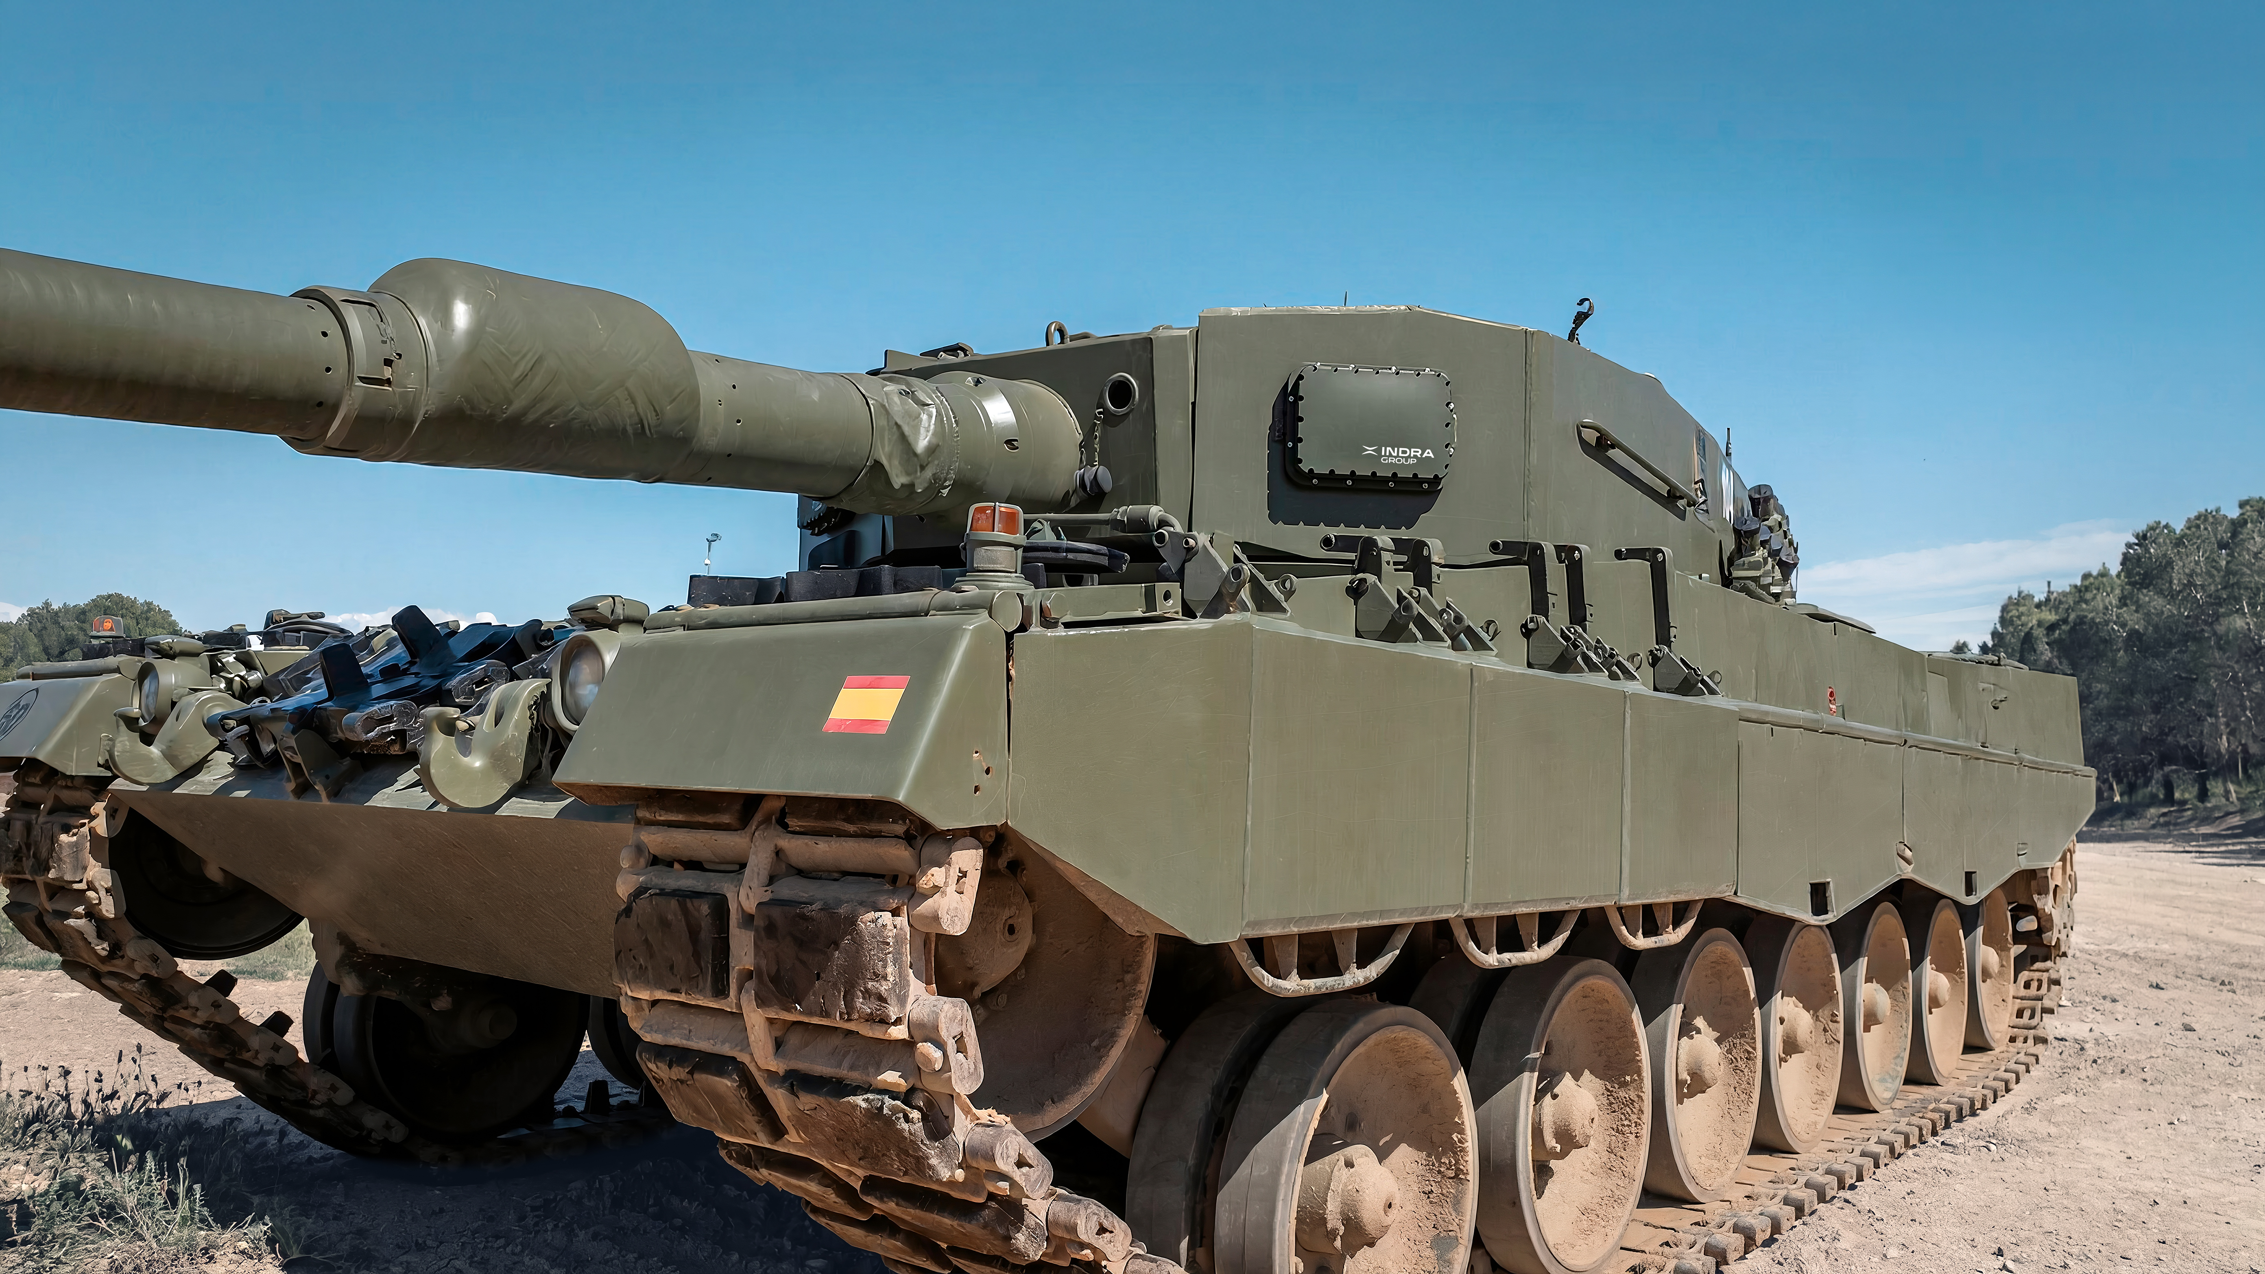

En At the EM&E stand, visitors will be able to see Indra’s AESA Nemus radar, mounted on a military vehicle. This is a state-of-the-art, compact and lightweight solution designed to enhance the protection of ground-based platforms.
This compact active electronically scanned array (AESA) system enables the detection, identification and real-time tracking of drones, microdrones and all types of projectiles, from anti-tank missiles to high-velocity ammunition, whilst also filtering out false targets and resisting attempts at electronic jamming.
The system is equipped with intelligence to distinguish between false targets and resist enemy attempts to interfere with its operation using jamming techniques (involving electromagnetic signals). It also stands out from other systems due to its ability to operate in extreme weather conditions, whether in high humidity, extreme cold or extreme heat.
Nemus automatically activates the necessary countermeasures to neutralise these threats, making it a key component of active protection systems in an environment characterised by the widespread use of drones and new munitions.

