CASE STUDY: THE APPLICATION OF AI TO 8X8
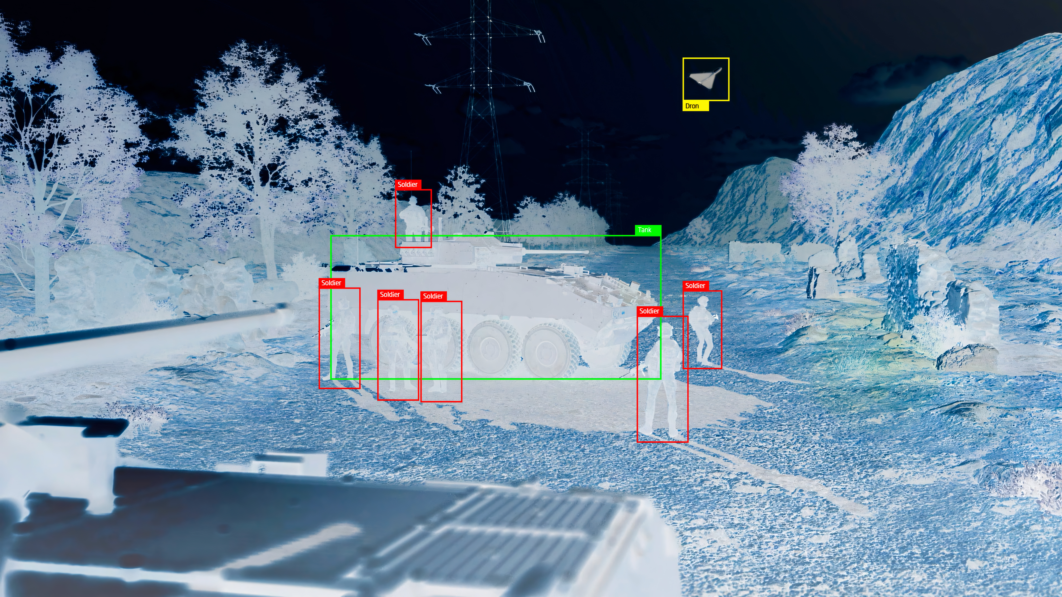

In the field of 8x8 vehicles, the application of artificial intelligence to 360° vision systems enables a significant improvement in situational awareness, by integrating and correlating information from sensors, mission systems and external sources in real time.
Using advanced data analysis and machine learning techniques, AI helps to identify threats, prioritise alerts and support the vehicle commander’s decision-making, thereby reducing the crew’s cognitive load and improving operational effectiveness in complex and highly dynamic environments.
Indra Group will showcase various use cases of artificial intelligence applied to 360° vision systems for military vehicles, using both Indra’s LSAS (Local Situational Awareness System) sensors and the “See-Through” 360° vision goggles.
These solutions incorporate an advanced intelligence layer that enables the identification of threats, the prioritisation of alerts and supports decision-making in complex operational environments, particularly in urban areas where response times are critical.
The IndraMind sovereign intelligence platform equips the vision system with the capability to analyse images in real time, detecting and identifying people and vehicles, distinguishing between friendly and enemy forces, assessing the threat level and the risk of ambushing, and proposing protective measures alongside the best possible course of action for the crew.
The use of artificial intelligence is particularly critical in highly complex scenarios, such as urban environments or low-visibility conditions, where the correct identification of attackers is more difficult and the window for response is significantly reduced. Unlike other systems, Indra’s 360° vision solution is not limited to environmental perception but incorporates advanced capabilities for understanding the operational context: it analyses data, recognises patterns and assesses how events affect the ongoing mission.
In this way, it automates key tasks and facilitates more agile, clear and informed decision-making in high-pressure situations, reducing the risk of errors and increasing the safety and effectiveness of the operation.

