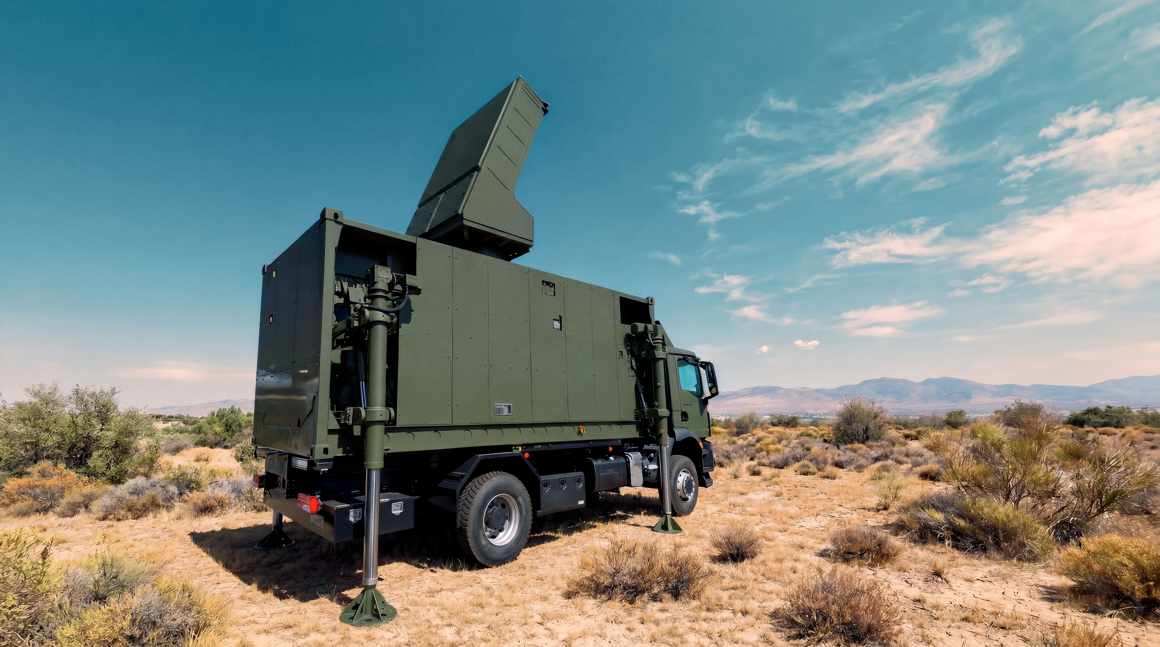
MTR 5 DEPLOYABLE RADAR

The MTR 5 is a counter-battery radar from the family of multi-function tactical radars featuring AESA (Active Electronically Scanned Array) technology, developed by Indra to operate in high-intensity scenarios and designed to perform air defence functions.
These radars are capable of detecting, geolocating and identifying moving targets both on the ground and in the air. AESA technology enables greater precision and speed in threat detection, making them an essential tool for defence and security.
This radar has been designed for counter-battery missions, short- and medium-range air defence and early warning; the system is capable of detecting, tracking and classifying a wide range of threats, from artillery shells, mortars and rockets to drones, aircraft and missiles.
The radar calculates the origin of enemy fire with great precision, alerts friendly units, provides data to interception systems and supports decision-making and the generation of counterattacks, integrating natively into command-and-control systems.
The MTR 5 is optimised for ground and counter-fire operations, offering high mobility and rapid deployment, combining air defence and surveillance functions, whilst maintaining a modular and open architecture that facilitates its integration into NATO networks and existing national systems.
MTR radars are designed to operate in adverse conditions and provide comprehensive airspace coverage, making them ideal for critical defence missions.
At Eurosatory, the MTR 5 will be installed in a shelter mounted on a Rheinmetall MAAN HX3 truck and can be viewed at their stand.

