ON-BOARD MISSION SYSTEM AND BATTERY MANAGEMENT SYSTEM (BMS)
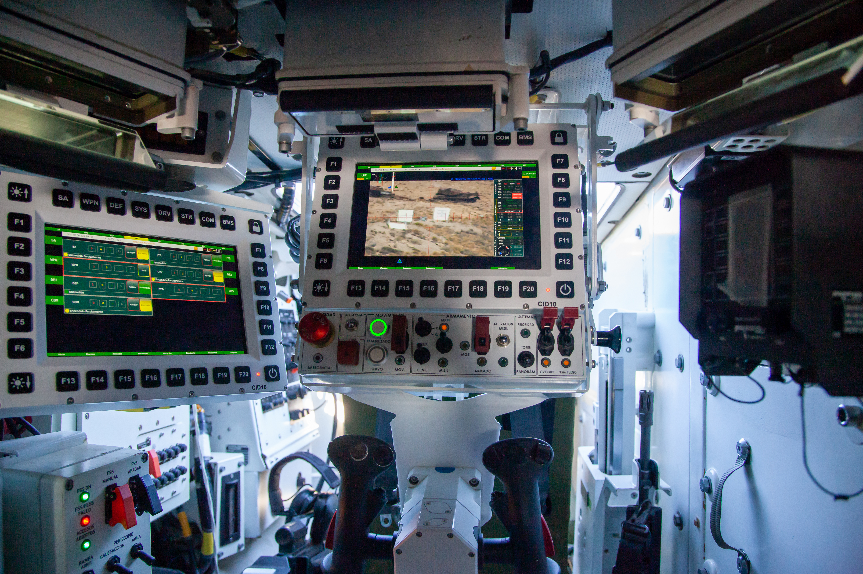

The Mission System and the Battlefield Management System (BMS) installed on the Dragón 8x8 VCR provide the vehicle with advanced intelligence and command-and-control capabilities.

The Maestre mission system for the 8x8 is the digital core that integrates, manages and utilises all the vehicle’s operational data, acting as the ‘brain’ that connects sensors, weapon systems, communications and decision-support systems, enabling the crew to access and control the vehicle via a simple, user-friendly interface that streamlines their work.

This Indra technology enables forces to carry out their duties in an increasingly collaborative environment, where tactical information is shared by geographically dispersed units to accomplish the mission. Indra will facilitate key aspects of this, such as ensuring that the information generated by the sensors streamlines the decision-making process, improves synchronisation, enables situational awareness and facilitates action, whilst ensuring the survival of forces across various operations, in what would constitute a complete operational cycle, from planning (ORBAT) through to debriefing, including the execution or conduct of the mission.

To this end, this Mission System is equipped with a high-performance electronic infrastructure and powerful capabilities for processing, analysing and storing information, both from the on-board equipment and from data relevant to the mission. Its open and modular architecture will facilitate the incorporation of new systems, such as the full LSAS suite—which is currently being pre-installed—as well as updates to the initial equipment in a straightforward manner throughout the vehicle’s entire lifecycle, thereby ensuring its technological advantage.

The BMS system, which shares an interface and is fully integrated with the mission system, enables units to share tactical information, their own and allied positions, and data from vehicle sensors and systems in real time. Natively integrated into the 8x8’s digital architecture, the BMS enhances situational awareness, speeds up decision-making and ensures interoperability with other systems and levels of command, making the Dragón a fully connected node in modern ground combat.

