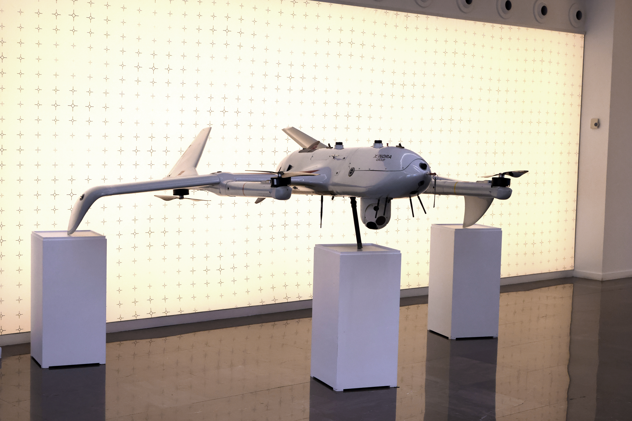
TARSIS-VTOL VERTICAL TAKE-OFF AND LANDING DRONE

The TARSIS-VTOL is an unmanned aerial vehicle capable of vertical take-off and landing, designed for tactical Intelligence, Surveillance and Reconnaissance (ISR) missions in complex environments.
It combines the operational flexibility of a VTOL, which allows it to operate without runways or infrastructure, with the flight efficiency of a fixed-wing aircraft to maximise range and mission endurance. Its modular architecture facilitates the integration of various sensors and payloads, and its autonomous navigation capability allows it to operate even in degraded environments or where GNSS is denied, significantly reducing the logistical footprint and expanding deployment options in land and naval scenarios.
It will also showcase its high-speed loitering munition solutions, designed to protect areas with a radius of up to 100 km, enabling precision air-to-ground strikes. These are unmanned, jet-propelled aerial munitions capable of flying at high speed and remaining on standby until receiving the order to attack, incorporating advanced guidance and navigation systems. It is a single-use system, optimised to provide a rapid and decisive response where it is critical to minimise the time between target detection and neutralisation.

